**DATA MAPPING**

By

Kim Alexander Mendoza

Jerico Cabotaje

Kent Bryan Carbayar

TUY PARISH MANAGEMENT SYSTEM

BSIT – BUSINESS ANALYTICS

**REPORTS**

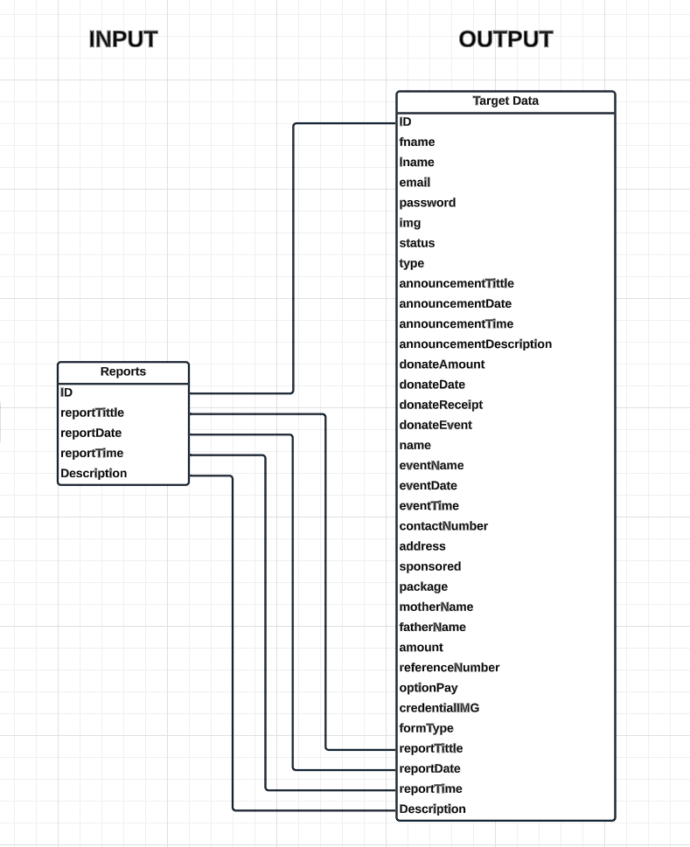

**EVENTS**

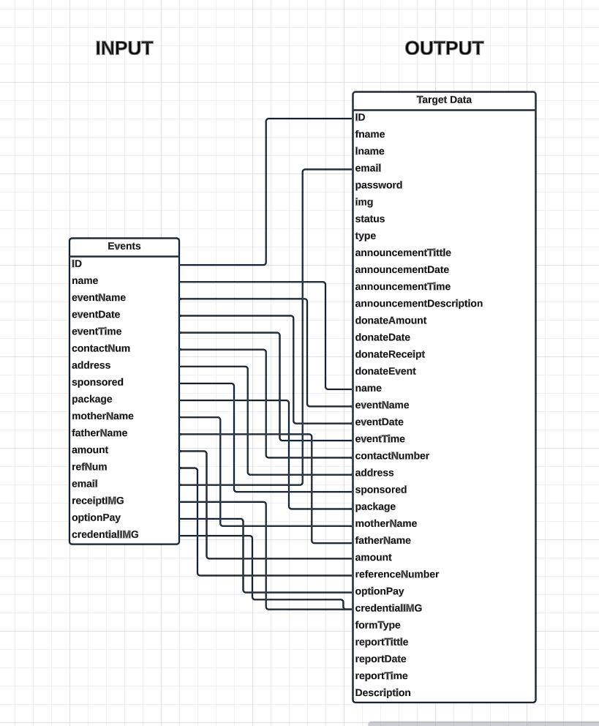

**DONATION**

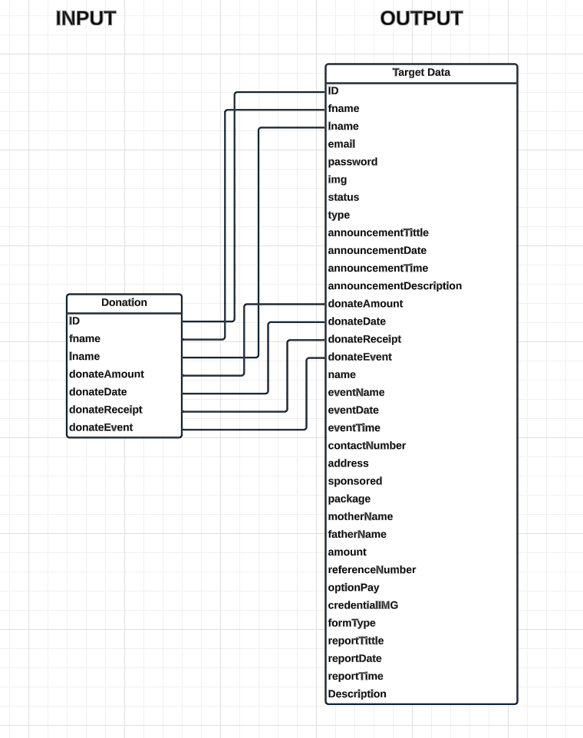

**ANNOUNCEMENT**

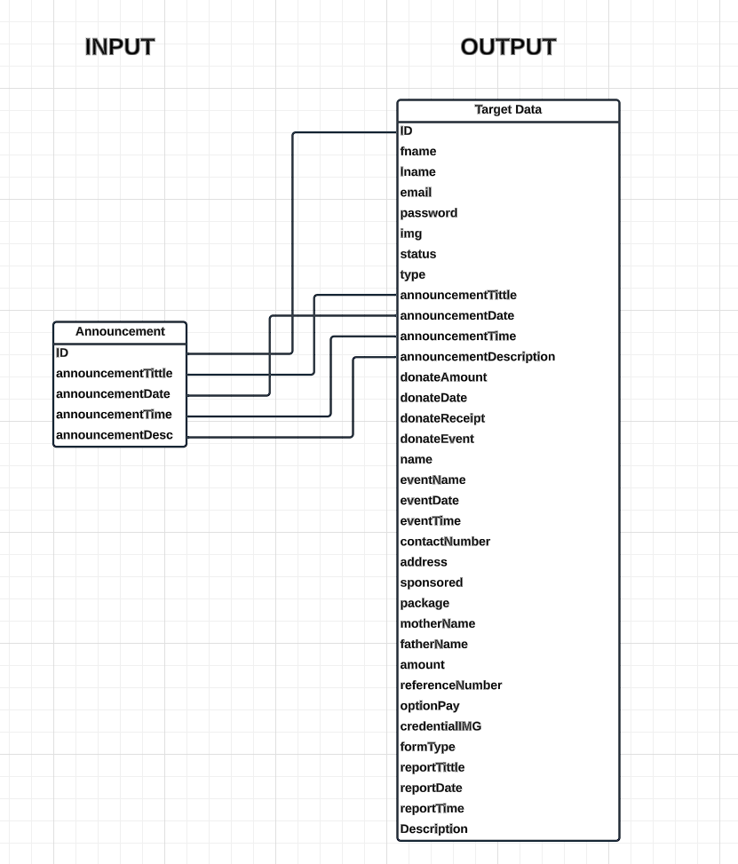

**ACCOUNTS**

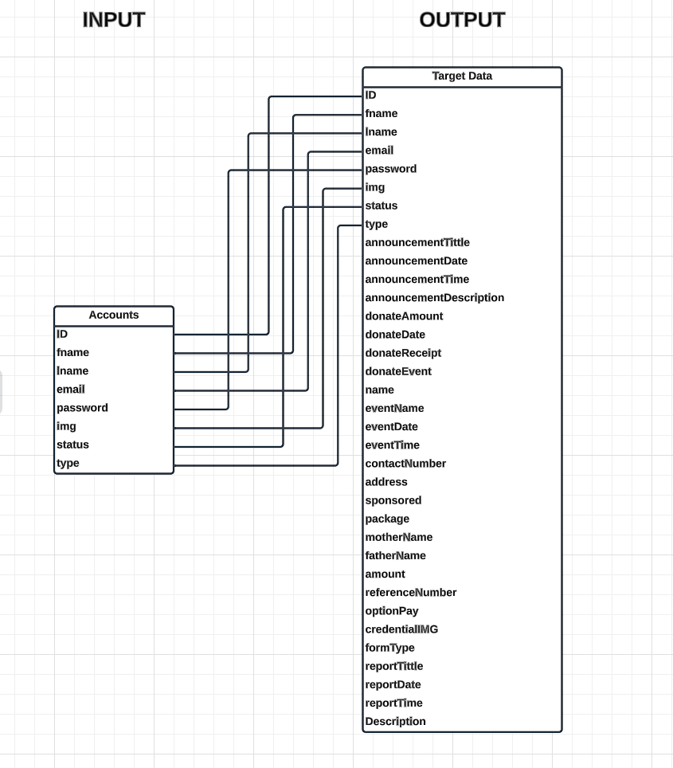

**REQUEST FORMS**

